Plug-ins:

Contact Form 7 - can manage multiple contact forms, plus you can customize the form and the mail contents flexibly with simple markup. The form supports Ajax-powered submitting, CAPTCHA, Akismet spam filtering and so on.

* At the left side menu bar click “Contact” of the customizing website. This where you can manage, create, customize or edit contact forms.

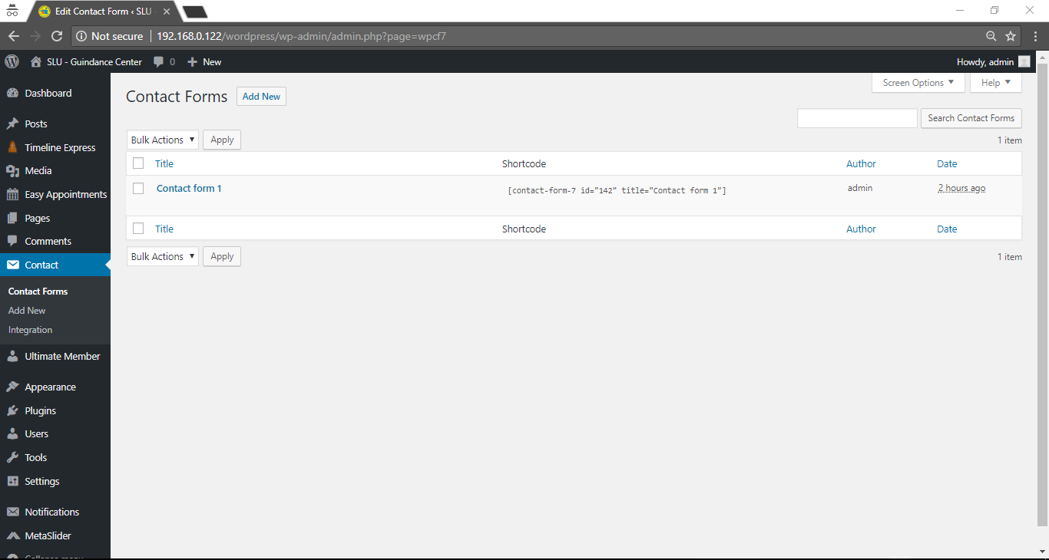

* In the website, fill in the requirement and submit the form.

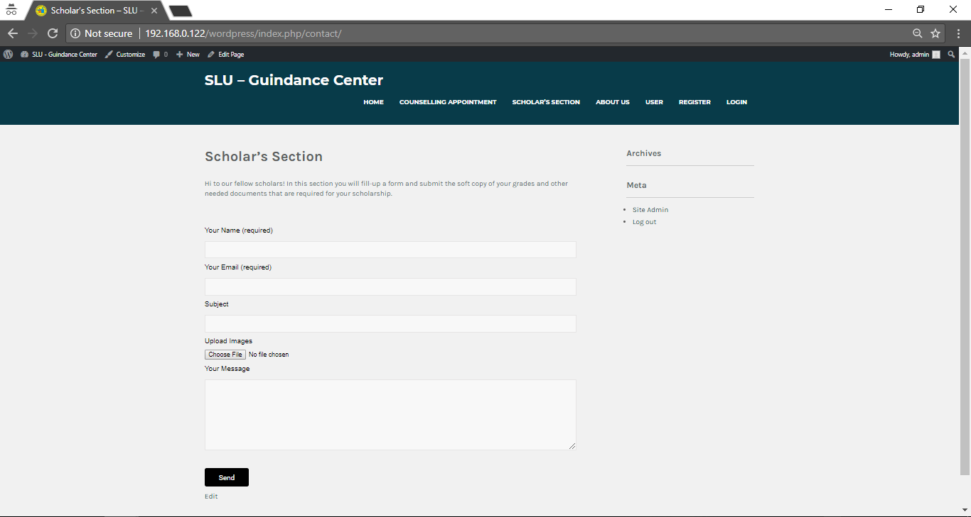

Easy Appointments - Add Booking Appointments system to your WordPress site and manage Appointments with ease. Extremely flexible time management. Multiple location, services and workers. Email notifications.

* At the left side menu bar click “Easy Appointments” of the customizing website. Where you can manage people, who are requesting for appointments or sending appointments schedules.

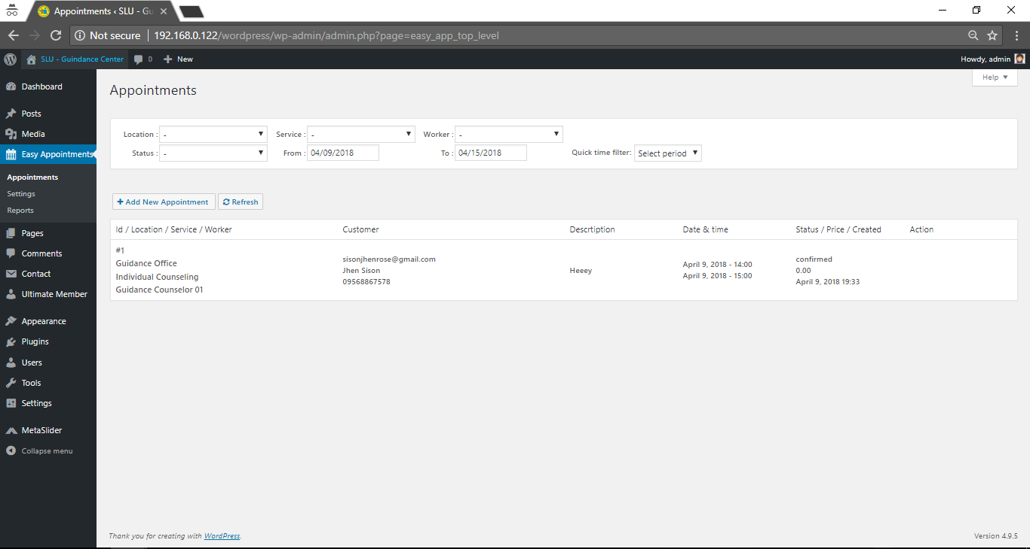

* In the website, shows requesting appointment forms for users.

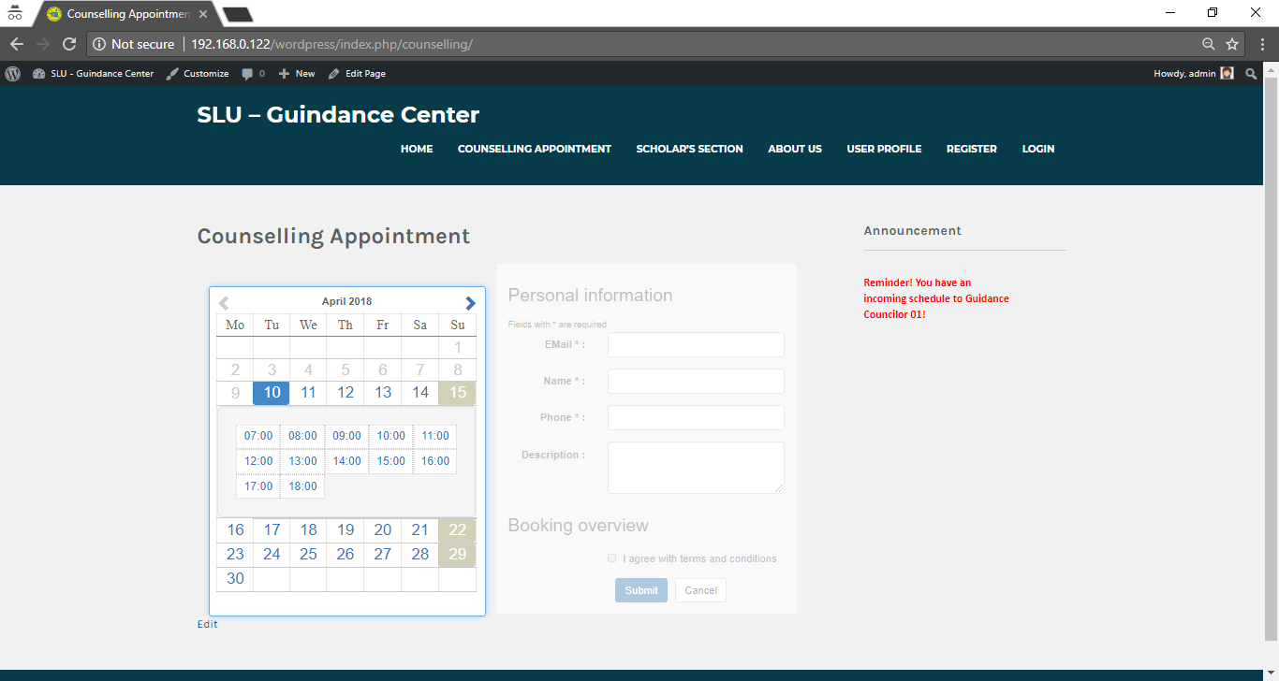

**MetaSlider** - can create your own unique, SEO-optimized slideshow in a matter of seconds.With WordPress’ most popular slider plugin, enhancing your blog or website couldn’t be easier: simply select images from your WordPress Media Library, drag and drop them into place, and then set the slide captions, links and SEO fields all from one page.

* At the left side menu bar click “Easy Appointments” of the customizing website. You can customize the slide that you are going to show to your slide show.

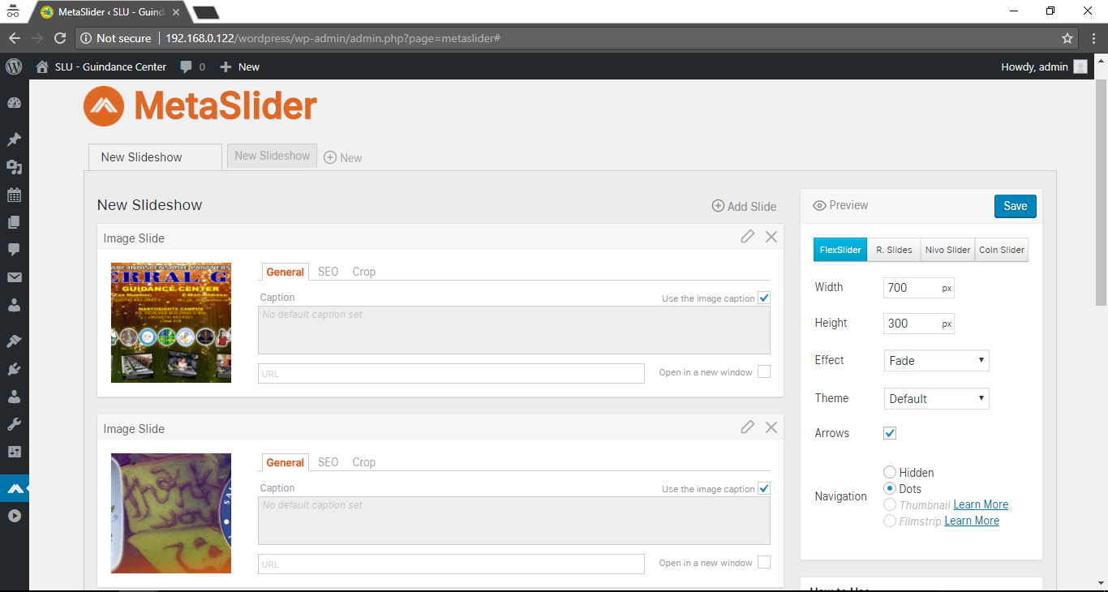

* In the website, you can see the slide show that shows the slide that you edit and entered.

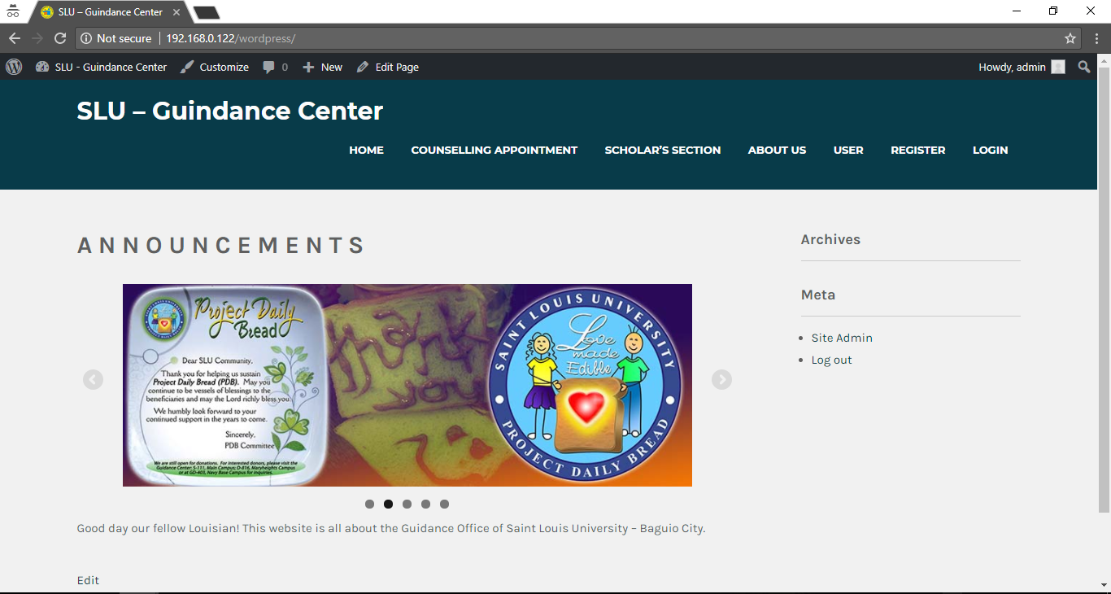

**News Announcement Scroll -** to display important announcements/upcoming events to their audiences. The news scroller keep your audience updated about the latest and the most important happenings on your website while giving you the option of adding link to the news. Using the News Scroller you can share offer updates, new blog updates, sale announcements, contest announcements, latest happenings etc all in one place so that the visitors can find it easily.

* At the left side menu bar click “Settings > News Announcement Scroll” of the customizing website. You can add, edit, delete announcement and any updates of the website.

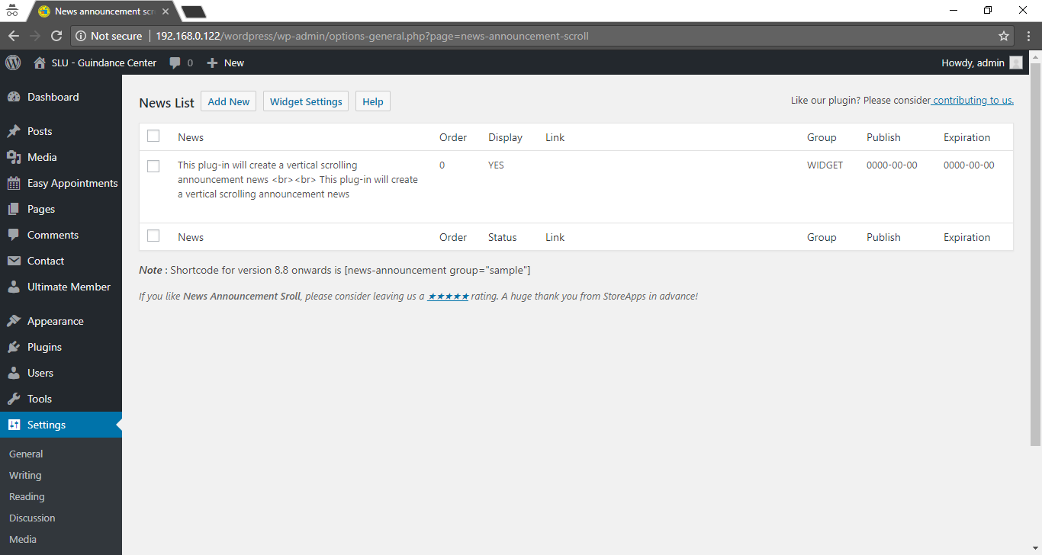

* In the website, It will appear above the slide show.

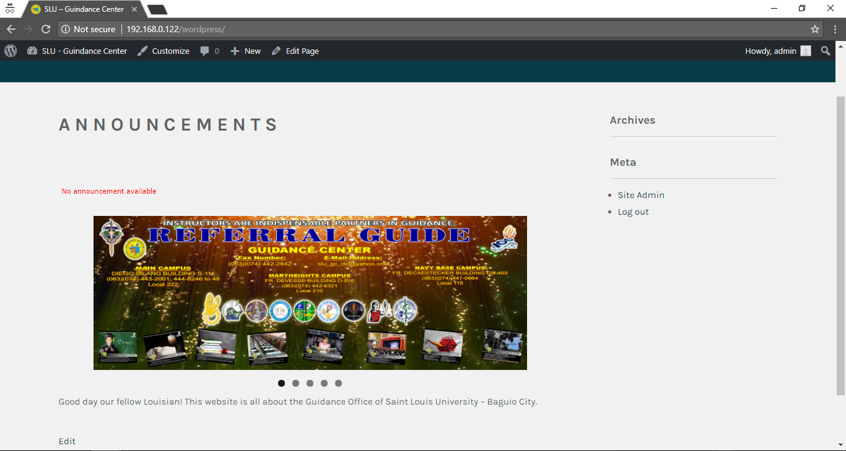

**Ultimate Member – a** user profile & membership plugin for WordPress. The plugin makes it a breeze for users to sign-up and become members of your website. The plugin allows you to add beautiful user profiles to your site and is perfect for creating advanced online communities and membership sites. Lightweight and highly extendible, Ultimate Member will enable you to create almost any type of site where users can join and become members with absolute ease.

* At the left side menu bar click “Ultimate Member” of the customizing website. This plugin you can manage users that are registered to the website.

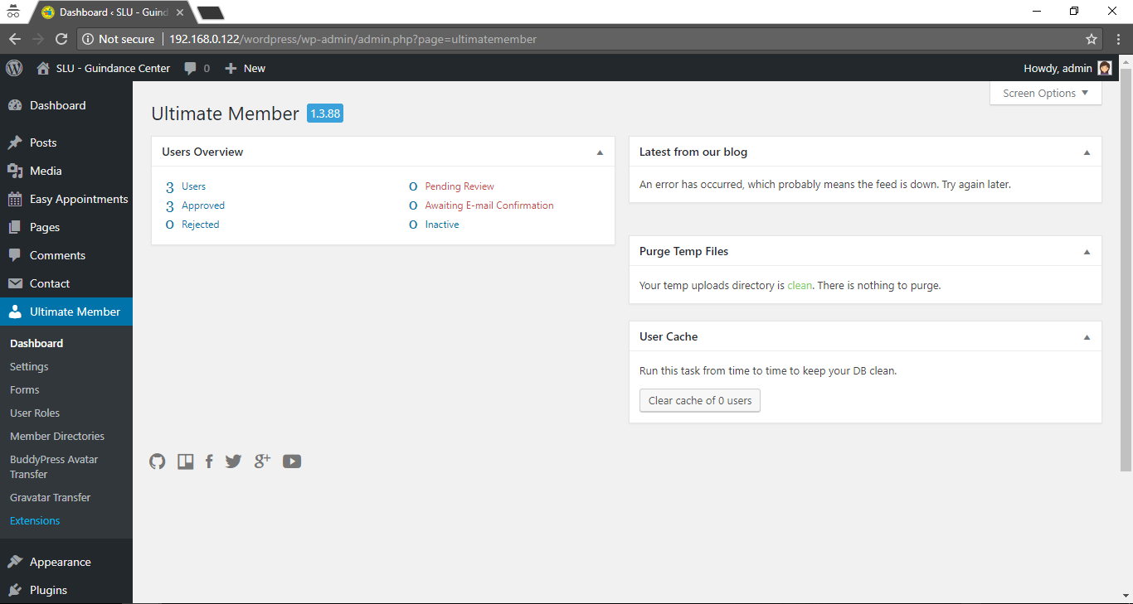

* In the website, it will show registration form where user can able register accounts to the website.

